COURSE INFORMATION
GENERAL PHYSICS II
PHYSICS 260
(Sections: 0301-0304 )

SPRING 2013

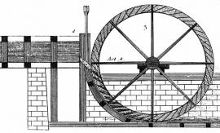

COURSE DESCRIPTION

PHYSICS 260 is the second of a three-semester introductory, calculus-based Physics course designed primarily for engineering students. The course presents an overview
of oscillatory motion, waves and wave phenomena, thermodynamics, electrostatics, and electrical circuits.
Emphasis is placed on understanding the basic physical concepts, relationships, governing laws, and principles, on APPLYING these laws and principles to simple physical MODEL systems, and on developing effective PROBLEM SOLVING strategies.

Course prerequisites are PHYS 161 and MATH141; the co-requisite, PHYS261, must be completed during this semester.
The semester grade is based on the LECTURE/DISCUSSION (75%), PHYS 260, and the LAB (25%), PHYS 261. A passing grade must be earned in both PHYS260 and PHYS261 to receive a single passing grade in the course.

COURSE INSTRUCTOR Dr Michael Rapport
docmrapp@gmail.com
Office : TBA
Office hours : M, W 2:00 - 2:50 and by appointment.

TEXT, . . . Knight, Randall D., Physics for Scientists and Engineers: A
Strategic Approach, 3nd Edition, Volumes 2, 3, and 4

COURSE COMPONENTS
ELMS/CANVAS | Course-related ANNOUNCEMENTS, ASSIGNMENTS, SOLUTIONS to QUIZZES, EXAMS . . . will be posted on the ELMS/CANVAS* course page… (*See www.elms.umd.edu/page/student-support )
LECTURE | Attendance strongly recommended.  Advice: Read assigned Chapter (Sections) before lecture !  See attached TENTATIVE LECTURE SCHEDULE.
DISCUSSION | Attendance mandatory. Attend assigned DISCUSSION section. Once weekly, conducted by Teaching Assistant. Consult class schedule for DISCUSSION meeting time and location. PURPOSE: Quizzes administered, questions answered, recommended chapter exercises/problems solved and discussed.
LAB | PHYS261 is a required co-requisite. Attendance mandatory. Passing grade must be earned to receive a single passing grade in course.

LECTURE GRADING SCHEME
EXAMS  40% | Three (3) EXAMS scheduled. EXAM scores will NOT be curved; lowest EXAM score will be dropped.  FORMAT: Problem Solving and Conceptual/Multiple Choice questions. Conceptual section, online !  Calculators required; equation sheet provided.
FINAL EXAM  25% | Cumulative FINAL. Details forthcoming.
QUIZZES and  ASSIGNMENTS  10% | Weekly, either a QUIZ and/or a HW ASSIGNMENT.  QUIZZES, administered in DISCUSSION. 10 point maximum. Notes, text, and calculator permitted.  ASSIGNMENTS, posted on ELMS/CANVAS. Collected in Lecture on due date. Late Assignments not accepted. Returned in DISCUSSION. 10 point maximum.  Best ten (10) QUIZZES and/or ASSIGNMENTS contribute to course grade.
RECOMMENDED  EXERCISES/  PROBLEMS | For practice, Recommended Chapter Exercises/Problems are provided; solutions to be posted. See the attached listing of Recommended EXERCISES/Problems.
COURSE GRADE | The FINAL COURSE grade is based on 75% LECTURE + 25% LAB.

IN ADDITION . . .
e-MAIL | Use the e-mail channel, docmrapp@gmail.com for course content questions, NOT for logistics questions/concerns.  You, the student, are responsible for the ‘who, what, where, and when’ of of the course; some options - pay attention to lecture announcements, find a reliable classmate, periodically check the ELMS/CANVAS ANNOUNCEMENTS . . .
NEED TUTORING or EXTRA HELP ? | Visit the SLAWSKY CLINIC - the Tutoring Center, PHY 1214 - A most valuable resource ! www.physics.umd.edu/academics/ugrad/slawsky.html  See Teaching Assistant during Office hours.  See Instructor during Office hours or by appointment.  Study groups are recommended.
STUDENTS with DISABILITIES | IMPORTANT: Meet with the instructor at the beginning of the course to arrange accommodations. DSS Documentation required.
ABSENCES and MAKE-UPS | No make-ups scheduled for exams, quizzes, or assignments.  Religious observances and extreme, extenuating, and documented circumstances are, of course, excepted.
ACADEMIC INTEGRITY | Academic Integrity and Honor Code in effect and will be enforced; see  www.studenthonorcouncil.umd.edu/whatis.html

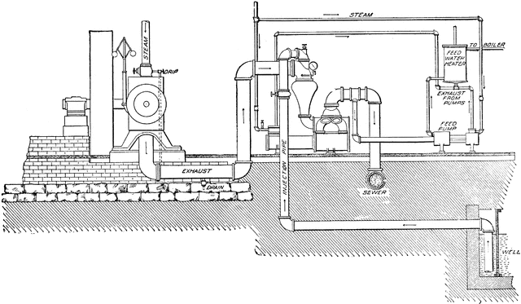
TENTATIVE LECTURE SCHEDULE
Text: Knight, R., PHYSICS for Scientists and Engineers :. . . ; 3nd Edition
DATE |  | LECTURE TOPICS | CHAPTER(Sections)
JANUARY
23 | W | INTRODUCTION ; COURSE OVERVIEW
25 | F | THERMODYNAMICS – The Basics | 16(1-7)
28 | M | THERMODYNAMIC PROCESSES and the FIRST LAW | 17(1-4)
30 | W | THERMODYNAMIC PROCESSES and the FIRST LAW | 17(1-4; 5-7)
FEBRUARY
1 | F | THERMODYNAMIC PROCESSES and the FIRST LAW | 17(5-7;8)
4 | M | THERMODYNAMIC CYCLES, IDEAL GAS | 19(1,2)
6 | W | THERMODYNAMIC CYCLES, IDEAL GAS | 19(1,2;3,4)
8 | F | THERMODYNAMIC CYCLES; The CARNOT CYCLE,… | 19(6)
11 | M | The CARNOT CYCLE – Thermal Engines, Heat Pumps, and Refrigeration Cycles | 19(5,6)
13 | W | The CARNOT CYCLE – Thermal Engines, Heat Pumps, and Refrigeration Cycles | 19(5,6)
15 | F | KINETIC THEORY | 18(2,3)
18 | M | KINETIC THEORY | 18(4,5)
20 | W | Simple Harmonic Oscillatory systems | 14(1-4)
22 | F | Simple Harmonic Oscillatory systems | 14(5,6)
25 | M | EXAM I – THERMODYNAMICS, Chapters 16-19
27 | W | Simple Harmonic Oscillatory systems | 14(7,8)
MARCH
1 | F | WAVES – The Basics | 20(1-3)
4 | M | WAVES and SUPERPOSITION | 20(1-3;6,7)
6 | W | WAVES and SUPERPOSITION | 21(1-3)
8 | F | WAVES and SUPERPOSITION | 21(5,6,7)
11 | M | MATTER, CHARGE, and COULOMB’s LAW | 25(1-4)
13 | W | COULOMB’s LAW and SUPERPOSITION | 25(1-4)
15 | F | COULOMB’s LAW and SUPERPOSITION | 25(1-4)
18 | M | SPRING RECESS
20 | W | SPRING RECESS
22 | F | SPRING RECESS
25 | M | The ELECTRIC FIELD | 25(5); 26(1-5)
27 | W | The ELECTRIC FIELD | 26(1-5)
29 | F | The ELECTRIC FIELD | 26(1-5;6)
APRIL
1 | M | EXAM II – Oscillatory Motion, Waves, Charge, Coulomb’s Law, and the Electric Field, Chapters 14, 20, 21, 25, and 26
2 | W | The ELECTRIC FIELD, Gauss’ Law | 27(1-4)
5 | F | The ELECTRIC FIELD, Gauss’ Law | 27(1-4;5)
8 | M | The ELECTRIC FIELD, Gauss’ Law | 27(5)
10 | W | POTENTIAL and POTENTIAL ENERGY | 28(4-7)
12 | F | POTENTIAL and POTENTIAL ENERGY | 28(4-7)
15 | M | The ELECTRIC FIELD-POTENTIAL CONNNECTION | 29(1-4)
17 | W | The ELECTRIC FIELD-POTENTIAL CONNNECTION | 29(1-4)
19 | F | The CAPACITOR | 26(5), 29(5-7)
22 | M | The ELECTRIC CIRCUIT – The Basics | 30(1,3,5)
24 | W | POWER DISTRIBUTION in ELECTRIC CIRCUITS | 31(3)
26 | F | CURRENT-VOLTAGE DISTRIBUTION in ELECTRIC CIRCUITS. KIRCHOFF’s LAWS | 31(1,2; 4-8)
29 | M | CURRENT-VOLTAGE DISTRIBUTION in ELECTRIC CIRCUITS. KIRCHOFF’s LAWS | 31(1,2; 4-8)

MAY
1 | W | CURRENT-VOLTAGE DISTRIBUTION in ELECTRIC CIRCUITS. KIRCHOFF’s LAWS | 31(1,2; 4-8)
3 | F | EXAM III - GAUSS’ LAW, POTENTIAL and POTENTIAL ENERGY, and CIRCUIT ANALYSIS, Chapters 27, 28, 29, 30, 31
6 | M | Odd’s ‘n Ends and REVIEW – PRACTICE FINAL
8 | W | REVIEW – PRACTICE FINAL
13 | M | FINAL EXAM, 6:30-8:30 pm; location TBA

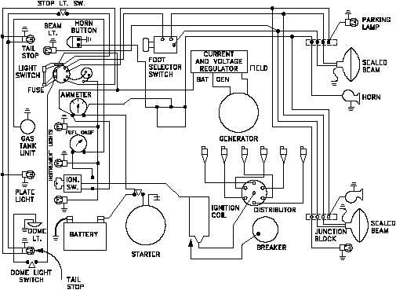

QUIZZES and ASSIGNMENTS

QUIZZES are administered in DISCUSSION; open notes, text, . . . 10 point, max. NO MAKE-UP QUIZZES
ASSIGNMENTS, typically one or two problems, are posted online and are to be submitted at the onset of lecture on the DUE DATE. 10 point, max. Late ASSIGNMENTS are not accepted.

Solutions to QUIZZES and ASSIGNMENTS will be posted online and may be discussed/solved in LECTURE and/or DISCUSSION.

WEEK of . . . | ASSIGNMENT:  Due Date | QUIZ | COMMENTS/Quiz Topic
21 January |  |  | WEEK 1, PHYS 260
28 January |  | Q1 | Ideal gas
04 February | A1: 02/08 | Q2 | Q_{i,f} = ΔE_{TH}
11 February | A2: 02/13 | Q3 | First Law Analysis, Thermodynamic processes
18 February | A3: 02/20 | Q4 | The Carnot Cycle
25 February |  |  | EXAM WEEK
04 March | A4: 03/04
11 March | A5: 03/15 | Q5 | Traveling Waves, D(x,t) = . . .
18 March |  | - | SPRING RECESS
25 March | A6: 03/27 | Q6 | Coulomb’s Law and Superposition
01 April |  | - | EXAM WEEK
08 April | A7: 04/12 | Q7 | The Electric Field
15 April | A8: 04/19 | Q8 | Gauss’ Law
22 April | A9: 04/26 | Q9 | Potential and Potential Energy
29 April |  |  | EXAM WEEK
06 May |  |  | REVIEW WEEK

RECOMMENDED EXERCISES/PROBLEMS
Physics for Scientists and Engineers: A Strategic Approach,
3rd edition, Randall D. Knight, Volumes 2, 3, and 4.

The RECOMMENDED EXERCISES/PROBLEMS highlight the basic concepts, relationships, and laws presented in each of the Chapters.
Attempt at least 65-70% of the RECOMMENDED EXERCISES/PROBLEMS for each Chapter – the problems offer an excellent review and provide a valuable tool for you to access your level of understanding. Seek assistance, if you are having difficulty solving these problems.
Solutions are posted online and some of the EXERCISES/PROBLEMS will be discussed both in lecture and in discussion.
NOTE: QUIZZES, ASSIGNMENTS, and EXAM PROBLEMS are fashioned, in part, after the RECOMMENDED EXERCISES/PROBLEMS !

Topics, CHAPTER (Sections) | RECOMMENDED PROBLEMS
Oscillations, 14(1-6)* | 11, 13, 19, 40, 45, 73
Macroscopic Description of Matter, 16(1-6) | 10, 27, 28, 29, 30, 56, 57, 64
Work, Heat, and the First Law of Thermodynamics, 17(1-8) | 2, 9, 11, 12, 16, 21, 24, 27, 31, 55, 56, 57,  59, 60, 65, 77
Kinetic Theory and the Second Law of Thermodynamics, 18(2-6) | 9, 11, 23, 29, 35, 60
Heat Engines and Refrigerators, 19(1-6) | 1-8; 9, 11, 13, 19, 20, 23, 25, 28, 31, 33,  37, 41, 42, 44, 46, 55-64
Traveling Waves and Wave Phenomena,  20(1-7) | 12, 17, 29, 36, 52, 56, 66
Superposition and Standing Waves, 21(1-7) | 9, 18, 25, 55, 63, 64, 66
Electric Charge and the Coulomb Force,  25(1-5) | 1, 3, 15, 17, 21, 33-44, 63
The Electric Field, 26(1-6) | 3, 7, 11, 13, 17, 23, 29, 31, 36, 40,  46, 50
Gauss’ Law, 27(1-6) | 1, 5, 9, 24, 32, 35, 37-40, 47,  48, 53, 54
Electric Potential and Potential Energy,  28(1-7) | 5, 7, 11, 19, 54, 63, 65, 67, 69
The Potential-Field Connection, The Capacitor,  29(1-7) | 8, 11, 14, 16, 20, 21, 25, 34, 40, 47,  51, 53, 55, 57
Electric Current and Resistance, 30(1,3,5) | 3, 9, 10, 26, 36, 39, 52, 61
The Fundamentals of Electric Circuits,  31(1-8) | 3, 5, 7, 9, 11, 13, 15, 16, 19, 21, 23, 29,  35, 37, 49, 50, 63, 67, 73
[*From PHYS 161, review Volume 1, Chapter 10 (4,5)]

