University of Maryland Department of Physics, College Park, MD 20742

Physics 273, Introductory Physics: Waves, Fall 2013

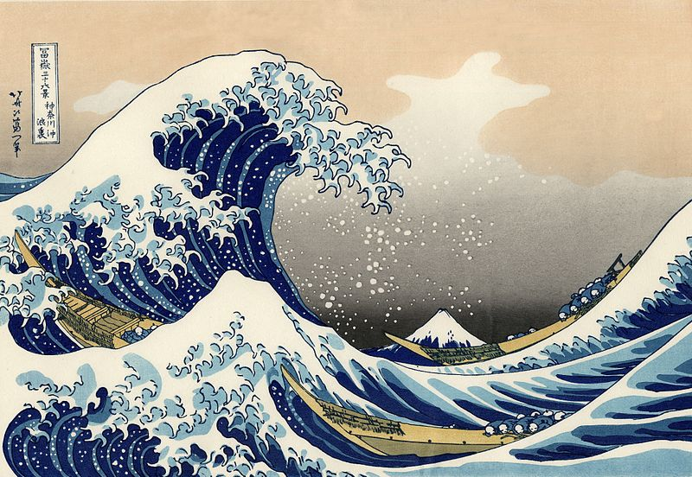

Instructor: Prof. Thomas Cohen (I prefer to be addressed as Tom)
Office: 3158 Physical Science Complex
Phone: 301-405-6117
E-mail: cohen@physics.umd.edu

TA:

E-mail:

Course Information and Assignments
Assigned readings, problem sets and exam dates will be made available on the courses Canvas page.

Time and Place:

T-Th 12:00-1:45 1204 Toll Physics Building

F 11:00-50 1201 Toll Physics Building

Office Hours
Official Office hours are from 10:00-11:00 Friday. I am also generally available in my office and happy to see students; just drop by--or, better yet, send me a email and then drop by.

Course Description
The official title of the course is Introductory Physics: Waves. In fact, the course is somewhat broader than this. It will, of course, deal with the physics of waves. However, more generally it will cover aspects of the physics of oscillations as well as waves; in addition it will provide an introduction to the mathematical techniques needed to describe vibrations and waves.

The physics and mathematics discussed in this course are interesting and important in their own right. Moreover, the various approaches used in this course constitute important paradigms in virtually all subjects of advanced physics.

Reading

There is no published textbook for this class. In place of a published text, we will be using the electronic text of David Morin. This is available on the course Canvas site. In addition it can be found at http://www.people.fas.harvard.edu/%7Edjmorin/book.html. Morin’s text is the basis of the vibration and waves course at Harvard. It is very clear and well written. Because it is a textbook in progress, it may be rough around the edges; if you spot any errors in it, please let me know so that I can communicate them to Dr. Morin. One difficulty with the text is that it does not have problems in it. I will assign problems separately and have list of problems on the courses Canvas site. However, there is one clear virtue of using this electronic text, namely the price: Dr. Morin has kindly allowed us to use it for free.

Readings will be assigned on a weekly basis. It is important to do the reading prior to class.

Lectures

The lectures will not follow the lectures identically, so it is critical to come to class. Every attempt will be made to use similar notation in lecture as used in the text.

Assignments and Grading Policies

- Problem sets: It is not possible to learn the material without working through problems. A list of problems will be given on the course Canvass site. Problems sets will be given from this list. However, the list will include extra, unassigned problems to give you a chance to work through extra problems.
  - Problem sets assigned on a weekly basis generally due Fridays

  - You are permitted—and encouraged—to work with classmates on problem sets. However, simply copying a classmate’s assignment is not allowed.

  - Rather than discussing the problem sets after they are submitted (and nothing is more deadly dull than that!) we will discuss the problem sets before they are due, typically in class on Thursday, the day before they are due. We will not solve the problems in class but if students are stuck and need help going forward, Thursday’s class is a time for help getting passed obstacles. It is imperative that you attempt the problem set before Thursday’s class. The discussion will be incomprehensible if you have not attempted the problem set.

  - One problem set grade will be dropped. This is so that the various exigencies of life do unduly affect your grade. A word of advice on this: Things do go wrong, so it is highly unwise to simply blow off one assignment early in the semester. You may really need it later!

  - Only a subset of the problems will be graded. Solutions will be providedon line for all the problems so you can make sure you understand the problems. To simplify the preparation of solutions exemplary student solutions may be reproduced (with the names omitted) as the solution. If you do not wish your solutions to be used in this manner, please indicate this on your homework.

A comment about homework: It is critically important to do the homework to learn the material. The data support this. Below is the median exam scores for groups of students based on the number of homework assignments they did not turn in the Fall 14 class; the correlation is quite striking.
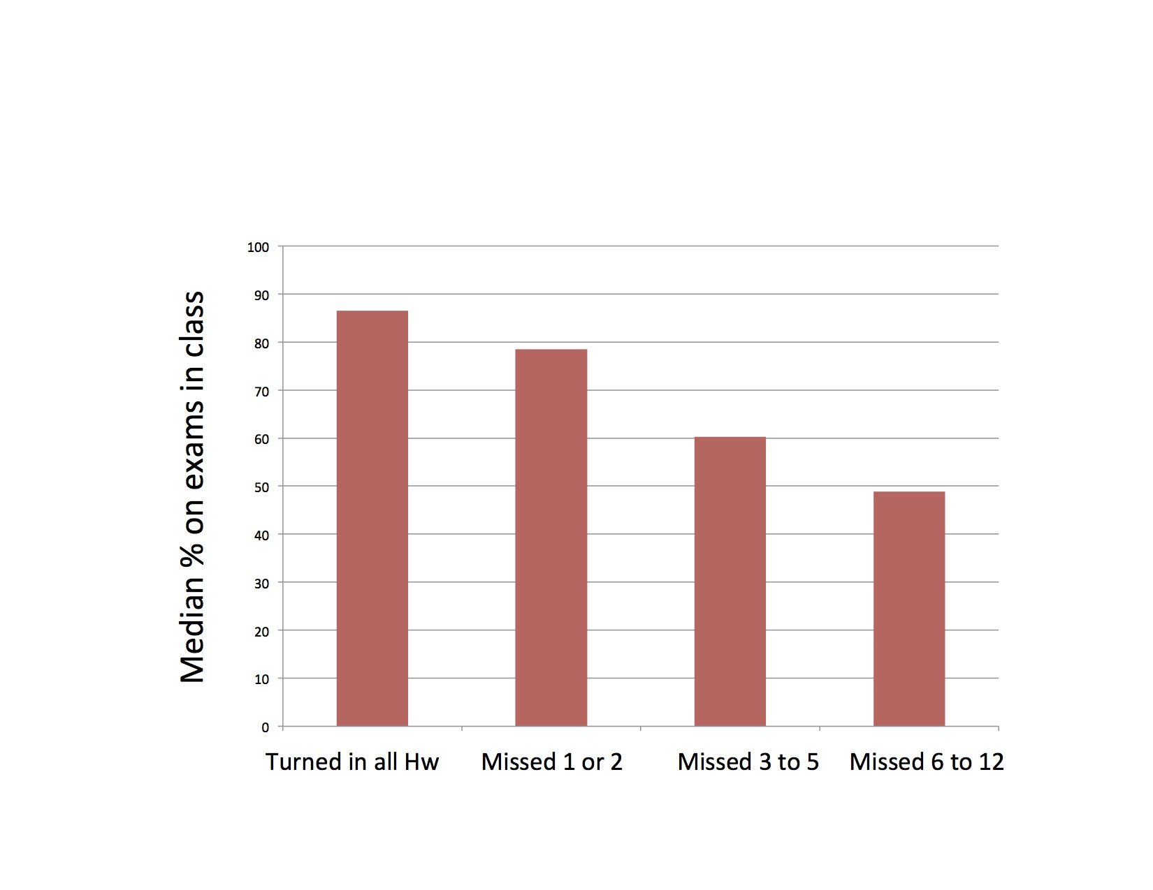
- Exams. There will be one midterm takehome exam and a takehome final.

Because the exams are takehome, it is imperative that all of you live up to the highest standards of intellectual integrity. In this regard, it is worth noting that science depends on the intellectual integrity of those engaged in it. Science depend on trusting that other scientists are not cooking the data. By giving takehome exams, I am depending on you to live up to the ethical norms of the field.

- Grading policies

  - Grades will NOT in general be given according to the scheme in which numerical scores greater than 90 corresponds to an A, between 80 and 90 a B etc. The reason for this is that assignments are of varying difficulty. Moreover, it is sometimes not clear even to the writer of an exam just how hard it is. Similarly the class will not be graded according to a rigid curve in which a predetermined fraction of students are given A’s , B’s etc. Rigid curves can lead to inequitable grade assignments. Instead, every attempt will be made to assign grades in a fair manner taking into account the actual difficulty of the exams.
  - To give students a sense of how they are doing in the class, grade distributions on the exams will be made available and the approximate correspondence between letter grades and exam scores will be given when exams are returned.
  - For PHYS 273 the approximate weight for the final is 15% problem sets, 85% exams.
  - For PHYS 272H the approximate weight for the final is 10% problem sets, 70% exams 20% project.

- Honors Section/PHYS 273H
The honors version of the course, PHYS 273H, meets at the same time and place as PHYS 273 meets. In addition to the work in PHYS 273, students in the honors section are responsible for an independent research project on a special topic related to waves. The goal of your research project is to learn in detail about a topic that is not covered in depth in class. At the end of the semester you will submit a paper describing the results of your project, and you will give a 15-minute presentation to the other honors students on your work.

Project Types: You are free to decide the scope and style of your project, subject to approval by the instructor. Here are several possibilities:

• Independent reading on a special topic. For this type of project, your final paper should be substantial (10-20 pages).
• Study of solutions of Maxwell’s equation which are more complex than plane waves.
• Write a program to do a complicated wave propagation calculation.
• Build an electronic device that uses a resonant circuit, like an AM radio.
• Holography
• Lasers and quantum optics
• Gravitational waves
• Seismology
• Come up with your own ideas........

Project Proposal: Write a proposal for your project, including the type of project and its topic. I will approve the proposal or suggest changes. You must turn in your project proposal to me by Friday September 25th and get final approval by October 2nd.

Final presentation: At the end of the semester, you will present the results of your project in a 15-minute presentation given to the students of PHYS 273H. We will arrange an appropriate time to meet, most likely during exam week.

Course Outline

- Oscillations. Topics include mechanical oscillators, oscillating circuits, damped and driven oscillators and systems of two coupled oscillators. Mathematical tools introduced to deal with these include complex exponentials, Fourier series and Fourier transforms.
Reading from Morin: 1.1, 1.2, 1.3, 2.1, 3.1, 3.2, 3.3, 3.4, 3.5
- Waves in 1-Dimension. Topics include transverse and longitudinal waves in one dimension, traveling and standing waves, energy and momentum in waves, reflection and transmission, impedance, dispersion.
Reading from Morin 2.4, 4.1,4.2, 4.3, 4.4, 4.5, 5.1, 5.2, 6.1, 6.2, 6.3
- Waves in higher dimensions. Topics include waves in two and three dimensions, plane-waves, electromagnetic waves, polarization, the Doppler effect, shock waves, interference and diffraction
Reading from Morin 7.1, 7.2, 8.1, 8.2, 8.3, 8.4, 8.5, 8.6, 8.7, 8.8, 9.1, 9.2, 9.3

